

HUMAN - COMPUTER INTERACTION SEMESTER 2 2023/2024

ASSIGNMENT 1 - FOGG BEHAVIORAL MODEL (FBM)

FACULTY: FACULTY OF COMPUTING

GROUP MEMBERS:
- AIN NURNABILA BINTI MOHD AZHAR (A23CS0207)
- SYARIFAH DANIA BINTI SYED ABU BAKAR (A23CS0183)
- DAMIYA AINA BINTI BASIR ABD SHAMMAD (A23CS0220)

ASSIGNMENT 1

a) Provide a brief description on the technology that you have chosen – generally, what is its purpose? (e.g. environmental awareness, managing diseases, living happily etc.)

We chose the Grab application which is an app available in Singapore, Malaysia, Cambodia, Indonesia, Myanmar, the Philippines, Thailand, and Vietnam for use in ride-hailing, food delivery, and digital payment services on mobile devices.

b) The Fogg Behavior Model asserts that for a target behaviour to happen, a person must have sufficient motivation, sufficient ability, and an effective trigger (note: trigger is now referred to as ‘prompt’). Describe TWO specific tasks or features of technology that requires the user to execute a “target behaviour”. By referring to the Fogg Behavior model in the reference paper given, discuss how the three principal factors (trigger, motivation, ability) persuade the user to execute that task or feature.

i) I think a positive rating and reviews is one of the most popular tasks from Grab. It is because by enhancing the app's reputation and drawing in new users, it encourages users to provide favourable ratings and reviews on grab App. Positive rating and review also give mutual benefits for both user and company. This means that the users’ reviews can give the company insight into what the consumers really desire, thus analysing them can help to understand overall user’s satisfaction. To elaborate more about the relationship between FBM and this task is because users will have a motivation to write a review when a service they use and get is good . This image shows the increment of their ability and the notification they will be prompted to order the service and rate them again.

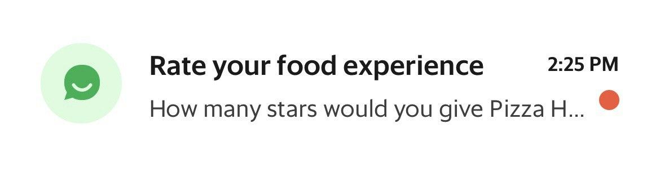

ii) Another task from Grab that requires the user to execute a “target behaviour” is utilisation of promotions to encourage customers to use the app's discounts and promotions more frequently, pointing out to them that doing so will increase their usage of the service. Users will receive in-app advertisement or promotion notifications from Grab such as promo codes, vouchers, seasonal promotions and targeted location-based promotions. Users will have to just simply click on the promotions and sometimes key in the promo code to utilise the promotion. The ability in terms of this specific target behaviour is just to click on the promotions and enter the promotion code. Users are supposed to have a high ability to do this because entering a code is as simple as copying the code and pasting it and clicking enter. In terms of motivation, users could have a high motivation to use the promotion codes due to wanting to save up on some expenses. For example, when users use Grab to order and get their food delivered, they will have to pay some extra fees such as delivery and service fees. By using the promo code, they could get as much as 50% off from the total charge and that could easily minus the total amount of service fees and make them spend less money on the food and save up some expenses.
For the prompt aspect, promotions are being displayed prominently to ensure that users are aware of the available discounts by highlighting the key words “voucher”, “gift card” and discount percentage that enhance the visibility and the effectiveness of the promotions. Users will be informed and prompted to check the availability of the promo code by clicking on the notification.

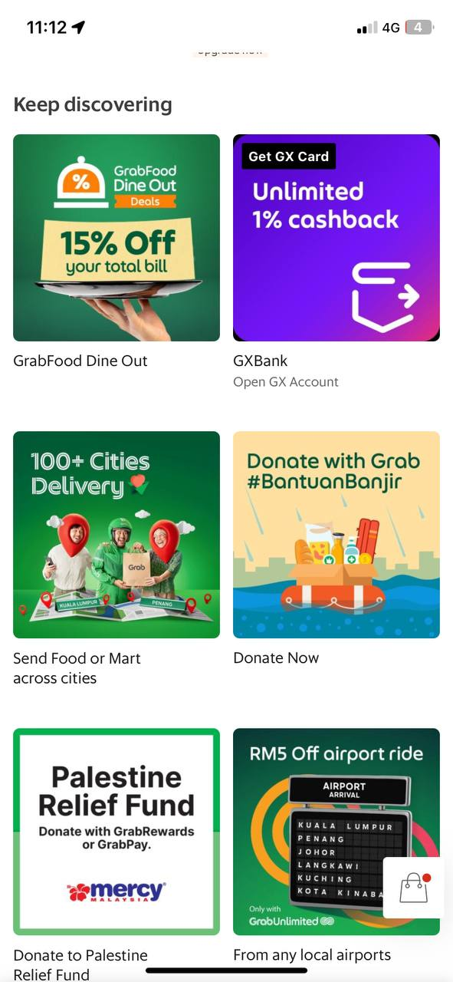
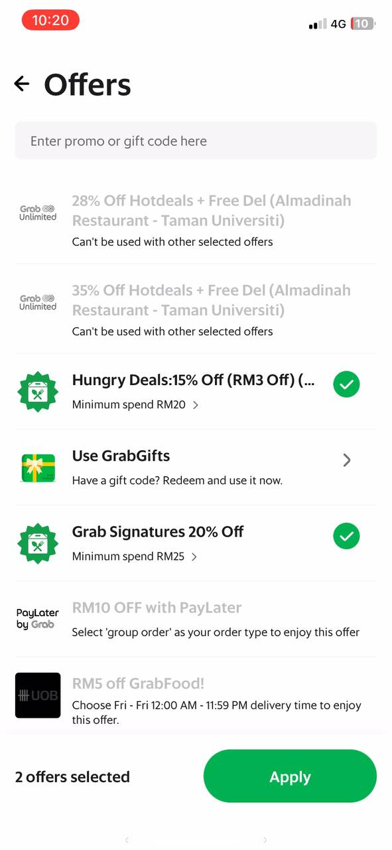
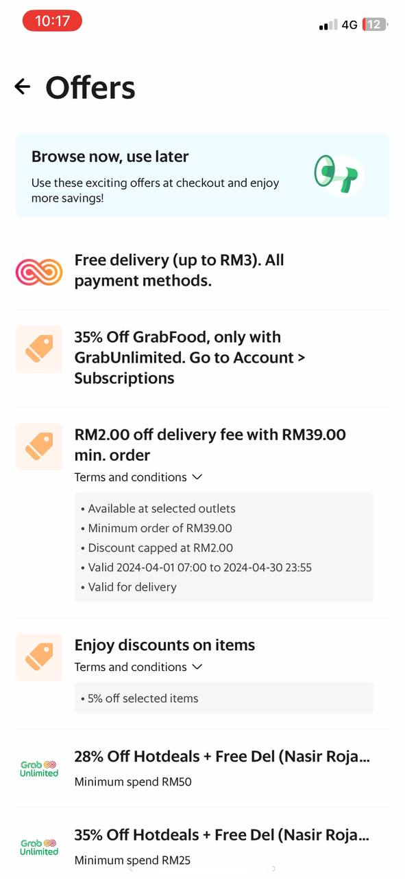

c) To support your discussion for (b), please also include a short video (you can screen record, or simply record the video using your phone) that demonstrates how the user is persuaded to execute that “target behaviour”. In the video, you must highlight the design elements that represent trigger, motivation, and ability, and how it combines to persuade a behaviour. Each video (one for each task) should be no more than 3 minutes.

d) Choose one feature of the technology which in your opinion fails to persuade a user to execute the target behaviour. Using the FBM, discuss why you think it fails and give suggestions/recommendations how the design of that feature can be improved. Please provide examples (with pictures) to support your discussions.

Given the diversity of users' habits and tastes, GrabUnlimited might not be a must for everyone. Paying for each ride or delivery may result in more savings from a subscription for people who don't commonly use ride-hailing or delivery services. Additionally, consumers have the freedom to select the most affordable option based on their needs thanks to Grab's platform's availability of promos, discounts, and alternate pricing alternatives. It might not be worth it for people to subscribe if they live or work in a place where Grab services are scarce. Furthermore, for consumers who can save money by paying for each use, the cost of the GrabUnlimited subscription could not be justified. In the end, whether or not a particular user needs GrabUnlimited depends mostly on personal tastes and budgetary constraints.
GrabUnlimited in Grab might not be necessary for all users due to its fixed cost structure, which may not provide significant savings for individuals who use ride-hailing or delivery services infrequently. To improve its appeal and utility, Grab could consider introducing more flexible subscription options tailored to different usage patterns. For example, offering tiered subscription plans based on the frequency of use could better accommodate diverse user needs. Additionally, providing additional perks or benefits exclusive to GrabUnlimited subscribers, such as priority booking, discounted fares for popular routes, or complimentary delivery upgrades, could enhance its value proposition. Moreover, enhancing transparency regarding potential savings and offering a trial period for new subscribers could encourage more users to consider and adopt GrabUnlimited, thereby increasing its relevance and appeal in the market.

